### **Photon Qubits : Understanding Applications & Current Research**

**Group 3**

### **Introduction**

Photon qubits and qudits are foundational elements in quantum information science, representing quantum states using photons. These "flying qubits" serve as carriers of quantum information due to their inherent advantages, such as high speed, minimal environmental interaction, and room-temperature operation. This document delves into their representation, functioning, and applications, along with ongoing research and challenges.

### **Understanding Photon Qubits and Qudits**

1. **What Are Photon Qubits?**  
   Photon qubits encode information in the quantum states of photons, utilizing properties like polarization, phase, and spatial modes. Common bases include horizontal (H) and vertical (V) polarizations, forming the computational basis for quantum operations.

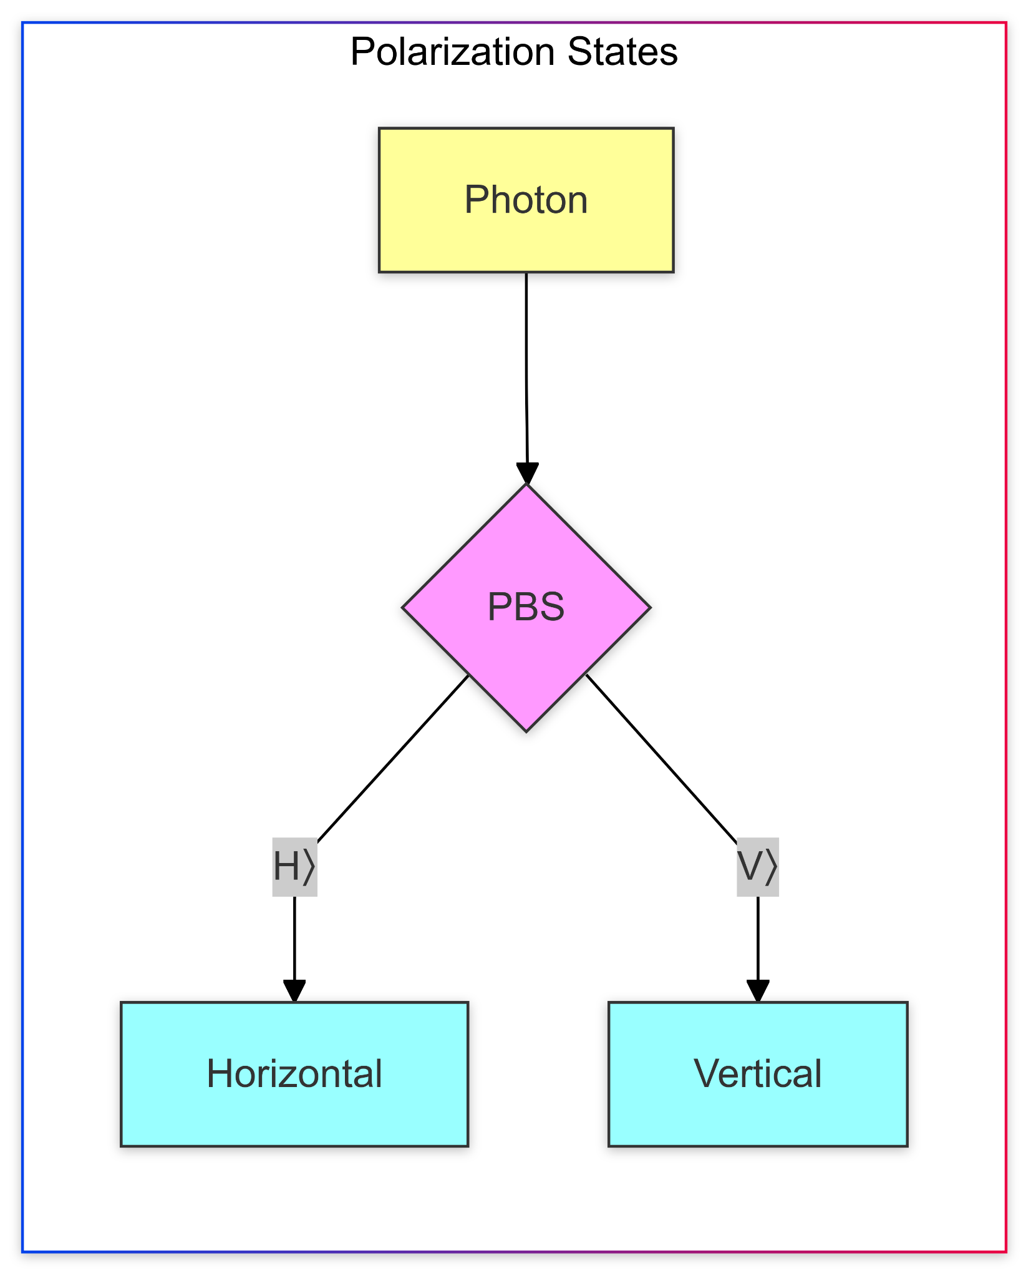

1. **How They Work:**
   * **Representation:** The state of a photon qubit, denoted as ( $ψ=α∣H⟩+β∣V⟩$**)**, is mapped onto a Bloch or Poincaré sphere for visualization.

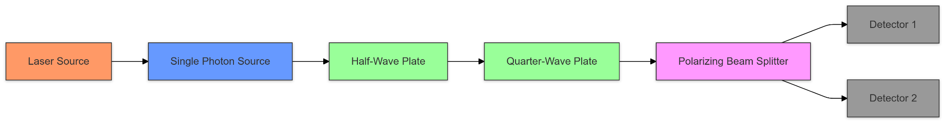

* + **Manipulation:** Optical elements such as waveplates (half-wave, quarter-wave) and polarizers allow precise control of polarization states. Waveplates introduce phase shifts, enabling rotations in the state space.
  + **Measurement:** Polarizing beam splitters and photon detectors measure polarization states, determining probabilities associated with quantum amplitudes.

1. **Photon Qudits:**  
   Extending beyond qubits, photon qudits leverage additional degrees of freedom, such as orbital angular momentum or multi-path interference, to represent higher-dimensional quantum states. This enhances information density and computational power.

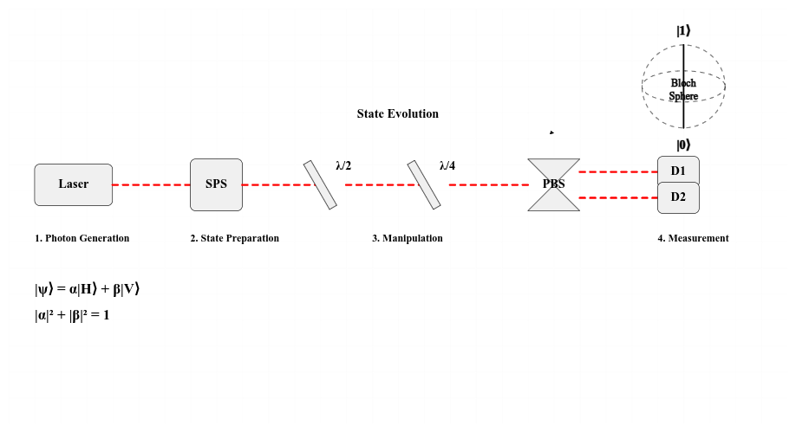

### **Applications and Use Cases**

1. **Quantum Communication:**
   * Photons are crucial for transmitting quantum information across networks, enabling secure quantum key distribution (QKD) and entanglement-based communication.
   * They serve as fundamental components in quantum repeater networks, which extend communication distances by mitigating photon loss and decoherence.
2. **Quantum Computing:**  
   Photon qubits enable all-optical quantum computing, leveraging linear optical elements and entanglement to perform operations.  
   Quantum gates, such as CNOT gates, are implemented through photon-photon interactions mediated by nonlinear materials.
3. **Quantum Sensing and Imaging:**  
   High-dimensional photon states improve resolution and sensitivity in applications like quantum microscopy and LIDAR.

### **Current Research and Challenges**

1. **Ongoing Research:**
   * Development of deterministic single-photon sources to improve reliability and scalability.
   * Advancements in multi-photon interference and integrated photonics for compact quantum devices.
   * Exploration of hybrid systems combining photons with other quantum memories for better storage and processing.
2. **Challenges:**
   * **Photon Loss and Detection Inefficiency:** Coupling photons into fibers and detecting single photons remain technologically demanding.
   * **Decoherence and Distance Limitations:** Attenuation in optical fibers hinders long-distance communication, necessitating repeaters and error correction.
   * **Scalability:** Scaling up to handle multiple photons and qudits simultaneously requires significant innovation.

### **Conclusion**

Photon qubits and qudits are pivotal in realizing practical quantum technologies. While their advantages in speed, coherence, and versatility make them ideal for quantum networks, overcoming challenges like photon loss and detection inefficiencies is critical. Current research focuses on optimizing photon-based systems and exploring hybrid approaches to unlock their full potential in computing, communication, and sensing. As quantum technologies evolve, photon-based systems promise to be at the forefront of a quantum-enabled future.